**Setup of MongoDB cluster**

1. Download MongoDB 3.0 and install it in C:\mongodb. You will see it installed with the following file or folders. Make sure bin folder is not empty.

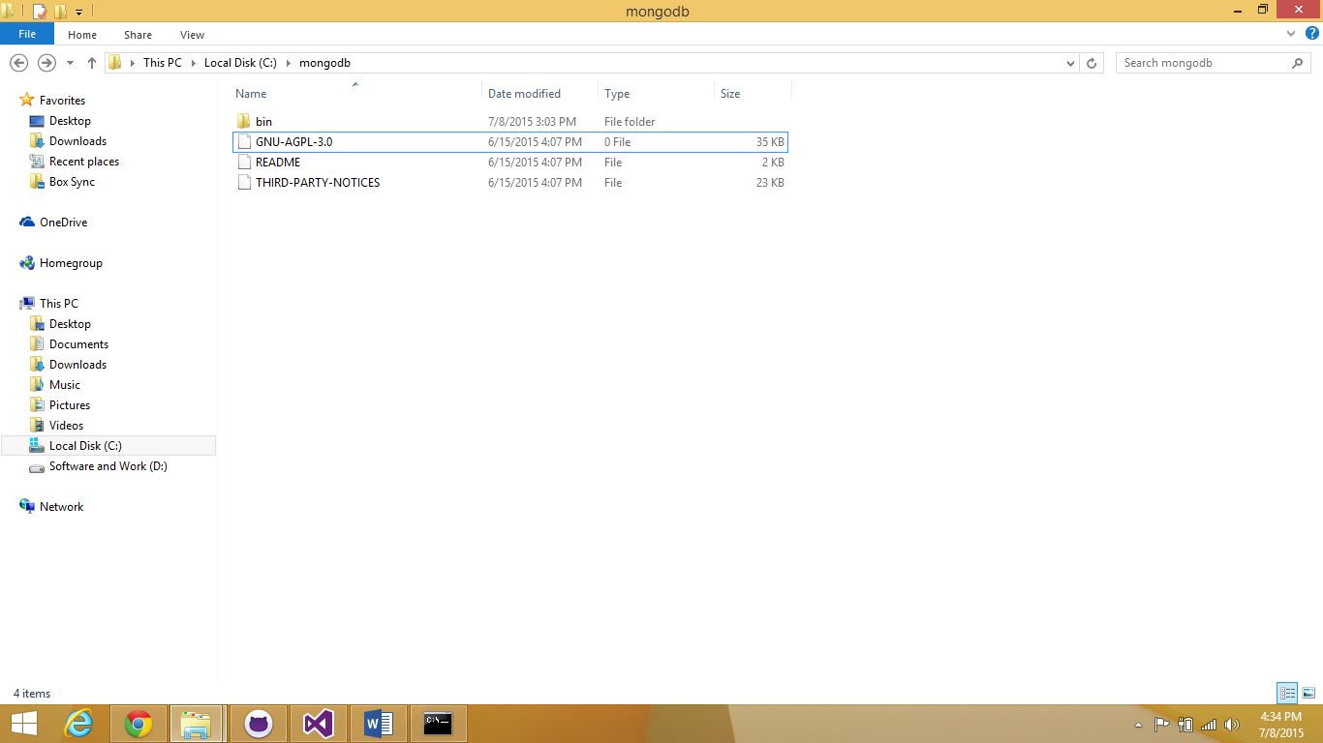

Figure : MongoDB install location

1. Open command prompt and change the directory to C:\mongodb. Now enter the commands as shown in screen shot

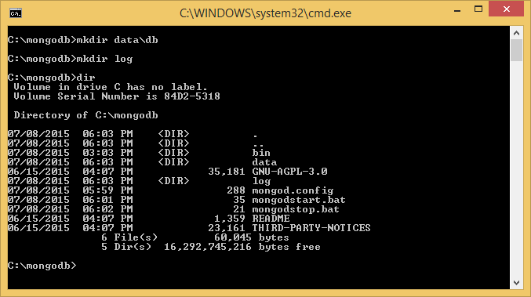

Figure : setup of data and log directories

1. Create start and stop windows batch script files (mongostart.bat, stopmongod.js and mongostop.bat) and mongod.conf file.
2. Mongod.conf file:

storage:

dbPath: "data/db"

directoryPerDB: true

journal:

enabled: true

systemLog:

destination: file

path: "log/mongodb.log"

logAppend: true

timeStampFormat: iso8601-utc

net:

bindIp: 127.0.0.1

port: 27017

wireObjectCheck : false

1. Mongostart.bat file:

bin\mongod --config mongod.config

1. Stopmongod.js

db = connect("localhost:27017/admin");

db.shutdownServer();

quit();

1. Mongostop.bat file

bin\mongo stopmongod.js

1. Open command prompt and execute the *start.bat file

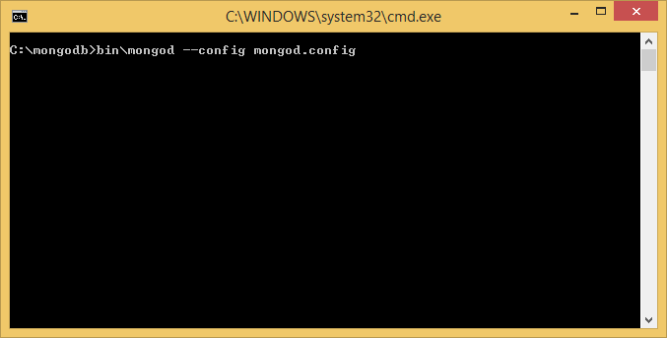

Figure : Starting MongoDB

1. Similarly to stop MongoDB execute the *stop.bat file OR kill the mongod process.